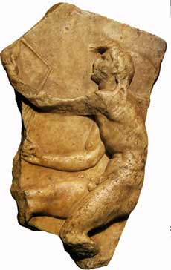
EUROCLASSICA

Annual Conference and General Assembly
Split, Croatia and Mostar, Bosnia-Herzegovina
(August 27–30 2021)

Second Message

Dear colleagues, in addition to the information given in the First Message, we now send the registration details.

Fees and costs
The registration fee is EUR 120. It includes the conference materials, coffee breaks, lunch on Friday, lunch and dinner on Saturday, city tour, entrance to Split Archeological Museum, and bus to Mostar and back.
The cost of the optional dinner on Friday is EUR 30. We have meat, fish, and vegetarian option.
The cost of the optional trip to the island of Hvar is EUR 25. It covers ferryboat, boat, city tour, and entrance to Petar Hektorović's villa.

Registration
To register please do the following by May 15:
- make your payment at the account given below (just add up the registration fee and the optional parts)
- fill the registration form at the following link: [X] (for each person separately; don't forget to click the "Submit" button)

Account details

Name: HRVATSKO DRUŠTVO KLASIČNIH FILOLOGA
Address: Ivana Lučića 3, Zagreb (postal code: 10000)
IBAN: HR6423600001101583404
SWIFT/BIC: ZABAHR2X
Bank: Zagrebačka banka d.d.
Bank address: Trg bana Josipa Jelačića 10, Zagreb (postal code: 10000)
Payment description: "Euroclassica registration - YOUR Family name and given name"

Hotels

Here we repeat the list of the some of the hotels at walking distance from the conference venue: Kastel (https://www.kastelsplit.com/en/), Globo (https://hotelglobo.com/), Bellevue (http://hotel-bellevue-split.hr/), President (http://www.hotelpresident.hr/split/).

Contact

For all issues regarding the registration please contact Šime Demo (sime.demo@gmail.com).

