Euroclassica Annual Conference and General Assembly 2026
Tbilisi – Vani, Georgia | August 19–22, 2026

Conference Host
Ivane Javakhishvili Tbilisi State University (TSU)
Institute of Classical, Byzantine and Modern Greek Studies
https://shorturl.at/BgIFK

Conference Partner
National Museum of Georgia
https://museum.ge/index.php?m=2

Conference Partners
Embassy of Greece to Georgia (tbc), UG School (tbc), European School (tbc)

Conference Venue
Ivane Javakhishvili Tbilisi State University (TSU)
1 Ilia Chavchavadze Avenue, 0179 Tbilisi, Georgia
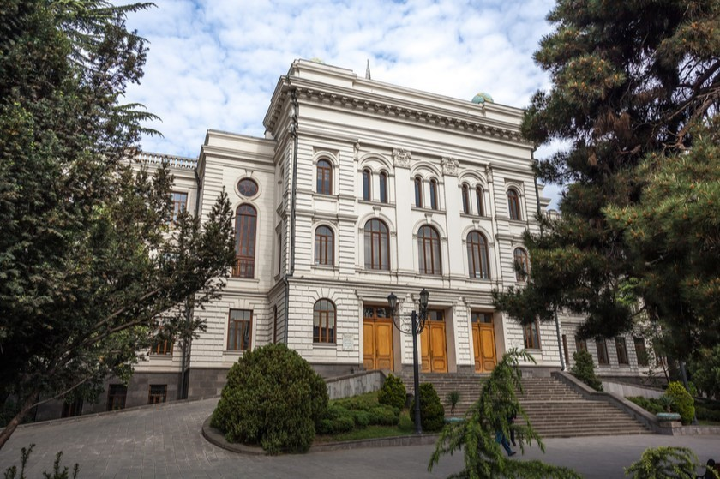

Conference Theme
Classical Languages – Between Tradition and Innovation (tbc)

Proposed Areas of Discussion (tbc)
- Interdisciplinary approaches in teaching classical languages
- Teaching classical languages and Artificial Intelligence
- Classical languages and performing arts
- Teaching classical languages in post-Soviet countries (panel discussion envisaged)
- Spoken classical languages

Draft Programme

August 19 (Wednesday)
- Arrival of participants
- Guided visit to the ancient capital of Georgia for the Conference Participants who arrive early morning – Mtskheta (UNESCO World Heritage Site) and Tbilisi city centre
https://whc.unesco.org/en/list/708/

August 20 (Thursday)
- Conference Sessions
- Guided city tour (for participants arriving on August 20)
- Lunch (offered by Tbilisi State University)
- Networking Dinner (offered by Tbilisi State University)
Family Photo:
After the first session, a group photo will be taken on the central stairs of the University building. Participants are kindly asked to follow the student volunteers.

August 21 (Friday)
- Conference Sessions
- Euroclassica General Assembly
- Visit to the National Museum of Georgia, guided by Associate Professor Dr. Nino Lordkipanidze
https://ug.edu.ge/en/persons/full/9296
- Reception at the Museum

August 22 (Saturday)
- Excursion to Dzalisi Archaeological Site
- Visit to the Otar Lordkipanidze Archaeological Museum in Vani, guided by Associate Professor Dr. Nino Lordkipanidze
- Lunch at the Museum (offered by the National Museum of Georgia)
Dzalisi Archaeological Site:
https://www.georgianholidays.com/attraction/archaeological-and-historical-sites/dzalisi

The Vani Archaeological Museum has received several international distinctions, including:
- World Award 2024 for its contribution to the preservation and promotion of Georgia’s cultural heritage
- European Museum of the Year Award 2023 – Silletto Prize for Community Participation and Engagement
- The Best in Heritage – Project of Influence Award
Video presentation of the Vani Museum:
https://www.youtube.com/watch?v=nYRG-jHbAGQ

Conference Communication
All conference materials will be shared through the social media platforms of Euroclassica, Tbilisi State University, the Institute of Classical, Byzantine and Modern Greek Studies, the Embassy of Greece, and other relevant channels, including the University Newspaper.
All sessions will be recorded and uploaded to the Institute’s YouTube Channel
https://www.youtube.com/@classicalb yzantineandmoder2971
Photographs will be taken during sessions and excursions. If you prefer not to appear in published materials, please indicate this during registration.

Organising Team
Student volunteers will assist participants during sessions, the General Assembly, and excursions. Their contact details will be shared prior to the Conference.

Financial Information
Provided by Tbilisi State University:
- Conference venue
- University-branded souvenirs
- Transportation for all excursions
- Lunch (August 20)
- Networking Dinner (August 20)
Provided by the National Museum of Georgia:
- Free entrance to the National Museum of Georgia
- Free entrance to Dzalisi Archaeological Site
- Free entrance to Vani Archaeological Museum
- Lunch in Vani
- Professional guided tours by Associate Professor Dr. Nino Lordkipanidze

Registration
Registration period: April 1 – June 1, 2026
(Registration link will be provided later)
Registration fee: 50 EUR

Contact
Chair of the Organising Committee:
Associate Professor Dr. Irine Darchia
Deputy Head of the Institute
Email: irine.darchia@tsu.ge
Phone / Viber / WhatsApp / Signal: +995 577 55 33 74
Members of the Organising Committee and student volunteers can be identified by distinct conference badges.

Logistical Information

1. Arriving to Georgia by Air
Participants may arrive via:

Tbilisi International Airport (TBS) - https://tbilisiairport.com/
The main international gateway with a wide network of direct connections to European cities, the Middle East, and Central Asia. Flights operate throughout the day.
If early-morning flights are inconvenient, Turkish Airlines via Istanbul is a convenient option, offering several daily connections.

Kutaisi International Airport (KUT) - https://www.kutaisi.aero/en
Often a more budget-friendly option, especially for European travellers. Many flights operate very early in the morning or late at night.

Travelling from Kutaisi to Tbilisi
- Direct shuttle bus (approx. 4.5–5 hours) - https://georgianbus.com/
- Train (approx. 4 hours) - https://gr.com.ge/en
- Taxi or private transfer (approx. 3–3.5 hours)
Participants arriving via Kutaisi may also consider staying in Kutaisi after the excursion to Vani, as it is geographically closer and may facilitate departure logistics.
Important: To secure better airfare rates, early booking is strongly recommended.

2. Airport Transfer within Tbilisi
We recommend using the international taxi service Bolt (https://bolt.eu).
Bolt vehicles are reliable, prices are transparent, and payment by card automatically generates an electronic receipt.
White airport taxis are available outside Arrivals; however, they are considerably more expensive and often do not provide receipts.
Most hotels can also arrange airport transfers upon request.
Please note that there is currently no direct train or regular city bus connection from Tbilisi Airport to the city centre.

3. Accommodation
Tbilisi offers a wide range of hotels. For proximity to the conference venue, we recommend accommodation in the Vake District.
Frequently used hotels by University guests:
- Hotel Orion – https://hotelorion.ge/
- Best Western Tbilisi City Center (Barnovi Street, Vake District) –
https://www.bestwestern.com/en_US/book/hotels-in-tbilisi/best-western-tbilisi-city-center/propertyCode.91456.html
As August is peak tourist season, early reservation of both flights and accommodation is strongly advised.

4. Practical Information

Currency
The currency in Georgia is the Georgian Lari (GEL).
Credit and debit cards are widely accepted in Tbilisi; less so in some regions. ATMs are readily available in the city centre.

Weather
Please consult:
https://www.accuweather.com/
https://www.yr.no/nb
Weather conditions in August are typically warm to hot.

Traffic
Heavy traffic is common in central Tbilisi. Please allow sufficient travel time if your accommodation is not within walking distance of the conference venue.

